COMMAND | RESULT
\? | Help. List all commands.
\l or \l+ | Show all databases on your server
\du | Show all roles in the database
\q or \quit | Exit Postgres cmd utility
CTRL+C  CTRL+D (Linux)  CTRL+Z (Windows) | Exit Postgres cmd utility
\d table_name or \dt table_name | To show a specific table in a database
\c database_name role_name | Access a database with specific role
\dn | List all schemas in the databse
\? | List all possible commands with psql
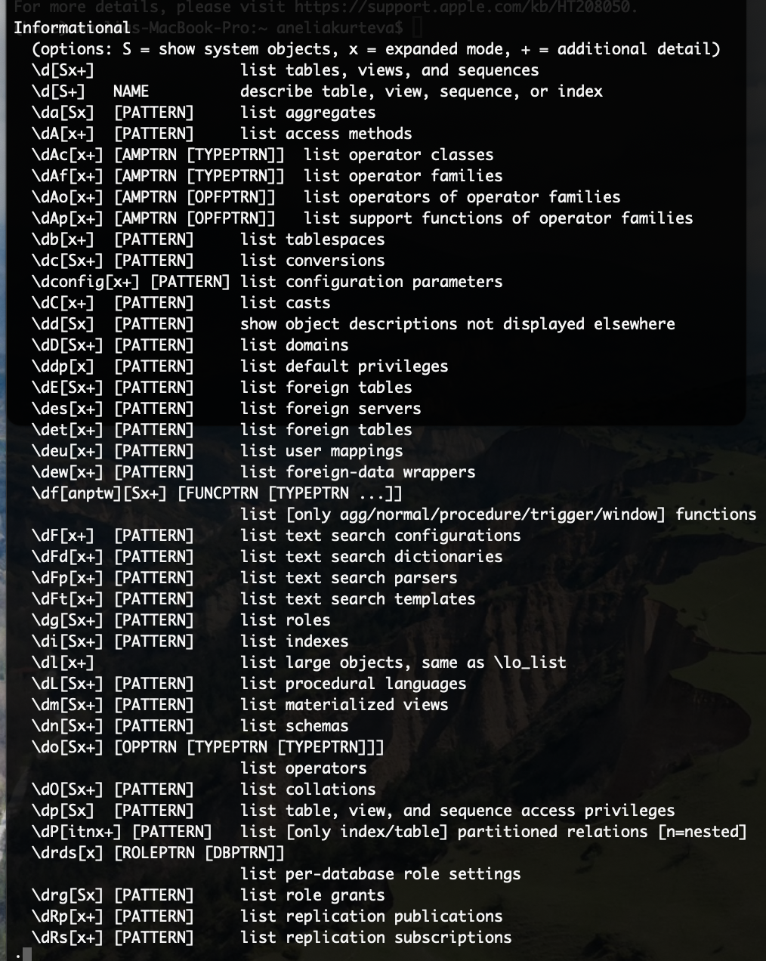

- Set up roles
CREATE ROLE cs_staff
NOINHERIT LOGIN PASSWORD 'password';

CREATE ROLE testuser
NOINHERIT LOGIN PASSWORD 'password';

\du

- Create a database room_booking

CREATE DATABASE room_booking
WITH
OWNER = cs_staff
ENCODING = 'UTF8'
CONNECTION LIMIT = -1;

- Create a database todo_list

CREATE DATABASE todo_list
WITH
OWNER = testuser
ENCODING = 'UTF8'
CONNECTION LIMIT = -1;

- Create a table within the database room_booking

\c room_booking cs_staff

CREATE TABLE public.room_booking
(
room_id text NOT NULL,
room_name text,
room_capacity integer,
room_zoom text,
PRIMARY KEY (room_id)
);

GRANT CREATE ON SCHEMA public TO cs_staff; ---- if this does not work:
\c todo_list postgres and GRANT ALL PRIVILEGES ON SCHEMA public TO cs_staff;

- Display the table room_booking
\d room_booking

- Create a table within the database todo_list

\c todo_list cs_staff

CREATE TABLE public.todo_item(
todo_item_id integer NOT NULL,
description text,
owner_id integer,
priority_id integer,
context_id integer,
status_id integer,
project_id integer,
due_date date,
completion_date date,
PRIMARY KEY (todo_item_id)
);

- Display the table todo_item

\dt todo_item

- Insert data in table todo_item

INSERT INTO public.todo_item
VALUES (0, 'New Task', 0, 0, 0, 0, 0, '2022-02-02', null);

or

INSERT INTO public.todo_item (todo_item_id, description, owner_id, priority_id, context_id, project_id, due_date, completion_date)
VALUES (1, 'Task 2', 0, 0, 0, 0, 0, '2022-02-02', null);

- Update existing data

UPDATE public.todo_item SET
completion_date = now()
WHERE todo_item_id = 0;

- Reading data

SELECT * from public.todo_item;

SELECT description from public.todo_item;
SELECT description from public.todo_item
WHERE todo_item_id=0;

- Deleting data from tables

DELETE FROM public.todo_item
WHERE due_date<’2022-02-03’; -> be careful with ‘’ in psql cmd!

- Deleting tables and databases
DROP table public.todo_item
DROP database todo_list

To delete or drop go back to superuser

\c postgres postgres
\DROP database room_booking

